**Project Deep Learning**

**Mask detection : “Are you wearing mask?”**

Lorenzo Pigozzi | m20200745

Marta

Gustavo

**Context (idea)**

This work is an academic group project for the course of *Deep Learning*, Master in Data Science and Advanced Analytics at *Nova Ims*.

The idea that gave birth to this project comes from a particular situation that is generated by the Coronavirus pandemic. The virus has changed our daily lives and habits, and one of the symbol of this new reality is for sure represented by this new “cloth” that all of us should wear in public spaces: face mask.

The face-detection is a problem that Machine Learning and in general AI has developed, and the machines have already achieved very significant results, with high probabilities of recognition.

But what about half of the face covered? Are we able to help the authorities to discover if people is actually wearing the mask in public spaces, as the social restrictions require?

In easier terms: are people actually wearing masks?

With these questions and inspirations, we start the creation of our model.

**Objective:**

The challenge we want to complete is the creation of a model able to detect automatically if, given an image-input, the person represented in that picture is wearing or not the mask.

**Problem discussion:**

1. What about many people in the same photo? Which kind of result should the machine return? And if one person have mask and one no?
2. Which kind of output do we want to be able to provide? Probability or just an output?

**ETL PROCESS**

Sources

**Images MASK**

Source website : <https://www.kaggle.com/andrewmvd/face-mask-detection/metadata>

Number : 1415

Description : In this dataset, we have mixed faces with masks only and images of groups of people with masks

**Images NO MASK**

Source website : http://chenlab.ece.cornell.edu/people/Andy/ImagesOfGroups.html

Number : 755

Description : In this dataset, we have mixed GROUP of people without masks

Source website : https://www.kaggle.com/ashwingupta3012/human-faces?select=Humans

Number needed : 1415 – 755 = 660

Description : In this dataset, we have close-up faces without masks

Total of MASK + NO_MASKS = 1415*2 = 2830

2822 images in the folders

**Problem Statement**

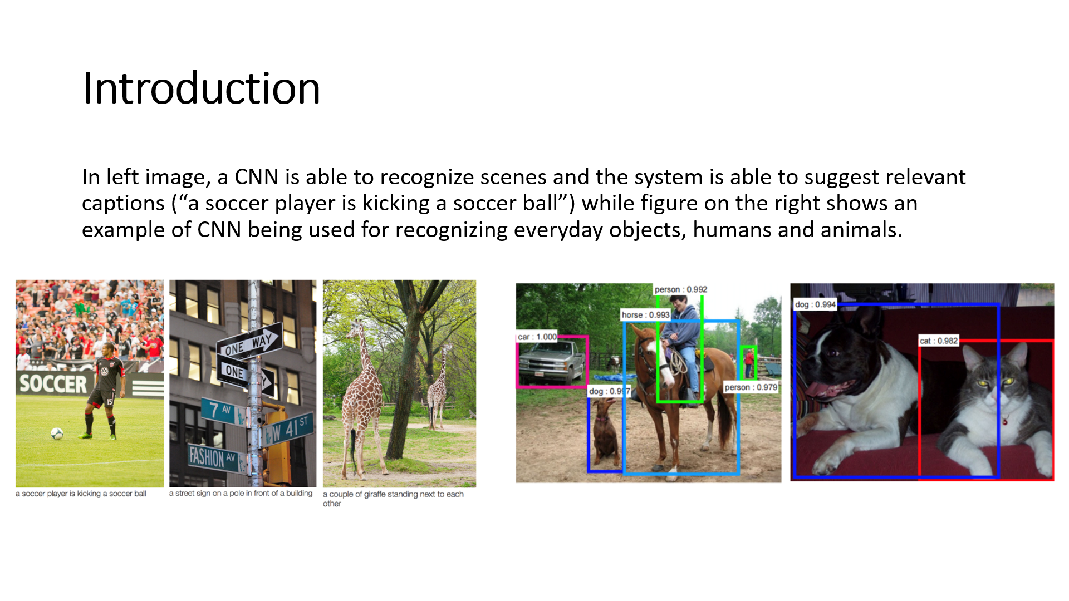

The idea of the CNN is that we provide the computer images that are read as array of numbers and it will output numbers that describe the probability of the image being a certain class (.80 for cat, .15 for dog, .05 for bird, etc).

In our case, we want to deal with a binary classification problem, in which we have 2 classes for the output : “mask” or “no mask”.

One of key points for the success of this classification problem is that we would be achieve a successful creation of filters in the convolutional process that will be able to detect the key characteristic that identify the 2 classes: the presence of the mask.

